

**BALDIVIS SECONDARY COLLEGE**

**YEAR 11 SPECIALIST MATHEMATICS 2020**

**INVESTIGATION 1**

**VALIDATION**

|  |
| --- |
| **INSTRUCTIONS:**  **Calculator allowed**  **Notes not allowed**  **Take-home section NOT allowed**  **Full working must be shown for all questions (or parts) worth more than 2 marks.**  **Marks will be deducted for rounding and unit errors.** |
| **Name: Time: 40 minutes Total / 25** |

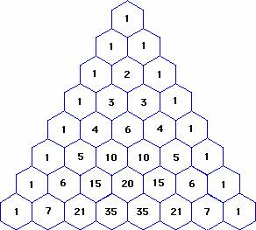

**Question 1 (5 marks )**

1. Expand 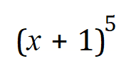 (1)
2. Comment on how the coefficients of 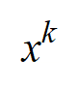 in 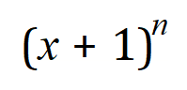 , 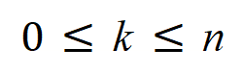 are related to the numbers in Pascal’s triangle (2)
3. Find, leaving your answer in the form 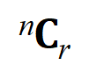 , the coefficient of 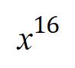 when 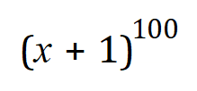 is expanded

(2)

**Question 2 (12 marks)**

Pick any number inside Pascal’s Triangle (i.e. excluding the 1s). Let this number be the centre of a flower. You will notice there are six numbers surrounding the centre and these form the petals of a flower. For example, if the 2 in line three is taken as the centre of the flower, then the petals are formed by 1, 1, 1, 1, 3 and 3, the numbers surrounding the centre.



If the number 15 in the 7th row is considered as the centre of the flower then the petals are 5, 10, 20, 35, 21 and 6.

It has been formulated that the product of one set of alternating petals is equal to the product of the other set of alternating petals. Starting with any petal, the product of the first, third and fifth “petals” is equal to the product of the second, fourth and sixth “petals”. For example 5×20×21 = 10×35×6

(a) Choose a centre and let it be equal to nCr. (You cannot choose 1 as the centre.)

Determine the expression for all six petals in terms of *n* and *r* in the form *aCb*. (4)

(b) Prove that the product of three alternate petals is equal to the product of the other three alternate petals. That is, *n-1Cr-1* × *nCr+1* × *n+1Cr*  = *n-1Cr* × *n+1Cr+1* × *nCr-1*  (8)

**Question 3 (8 marks)**

The triangular numbers are 1, 3, 6, 10, 15…..because the units can be arranged to form triangles as in the diagram below



1 3 6 10

Locate the triangular numbers on Pascal’s Triangle.



(a) (i) Using *n* = 1 for the second row; the one containing 1 1, determine an expression

for *Tn,* i.e. the *n*th triangular number, in terms of *nCk*. (2)

(ii) Test your rule by obtaining the value for *T6*, the 6th triangular number, 21 (1)

(b) Prove that the sum of any two consecutive triangular numbers is equal to a square number

(5)

The following diagrams may be useful:

|  |  |  |  |  |  |  |  |  |  |  |  |  |  |  |
| --- | --- | --- | --- | --- | --- | --- | --- | --- | --- | --- | --- | --- | --- | --- |
|  |  |  |  |  |  |  | 1 |  |  |  |  |  |  |  |
|  |  |  |  |  |  | 1 |  | 1 |  |  |  |  |  |  |
|  |  |  |  |  | 1 |  | 2 |  | 1 |  |  |  |  |  |
|  |  |  |  | 1 |  | 3 |  | 3 |  | 1 |  |  |  |  |
|  |  |  | 1 |  | 4 |  | 6 |  | 4 |  | 1 |  |  |  |
|  |  | 1 |  | 5 |  | 10 |  | 10 |  | 5 |  | 1 |  |  |
|  | 1 |  | 6 |  | 15 |  | 20 |  | 15 |  | 6 |  | 1 |  |
| 1 |  | 7 |  | 21 |  | 35 |  | 35 |  | 21 |  | 7 |  | 1 |

|  |  |  |  |  |  |  |  |  |  |  |  |  |  |  |
| --- | --- | --- | --- | --- | --- | --- | --- | --- | --- | --- | --- | --- | --- | --- |
|  |  |  |  |  |  |  | 0C0 |  |  |  |  |  |  |  |
|  |  |  |  |  |  | 1C0 |  | 1C1 |  |  |  |  |  |  |
|  |  |  |  |  | 2C0 |  | 2C1 |  | 2C2 |  |  |  |  |  |
|  |  |  |  | 3C0 |  | 3C1 |  | 3C2 |  | 3C3 |  |  |  |  |
|  |  |  | 4C0 |  | 4C1 |  | 4C2 |  | 4C3 |  | 4C4 |  |  |  |
|  |  | 5C0 |  | 5C1 |  | 5C2 |  | 5C3 |  | 5C4 |  | 5C5 |  |  |
|  | 6C0 |  | 6C1 |  | 6C2 |  | 6C3 |  | 6C4 |  | 6C5 |  | 6C6 |  |
| 7C0 |  | 7C1 |  | 7C2 |  | 7C3 |  | 7C4 |  | 7C5 |  | 7C6 |  | 7C7 |

